To address the complexities of autonomous navigation within a pirate-themed maze, I developed a Deep Q-Network (DQN) in Python, employing the GameExperience and TreasureMaze classes to serve as the primary environment. The agent was confined to a four-directional action space encompassing forward, backward, left, and right movements and utilized reinforcement learning (RL) to determine the most efficient trajectory toward the treasure. This training utilized a reward-based feedback loop, a foundational method in environmental interaction and decision-making (Liang et al., 2025). By providing positive reinforcement for reaching the objective and issuing penalties for collisions, invalid actions, or redundant square visits, the agent successfully developed an action-selection policy aimed at maximizing its cumulative expected reward (Chen et al., 2021).

A critical component of this learning process was the dynamic equilibrium between exploration and exploitation. While exploration involves selecting unfamiliar actions to gather new environmental data, exploitation focuses on utilizing existing knowledge to maximize immediate rewards (Liang et al., 2025). To manage this balance, I employed an (ε)-greedy strategy combined with a decay schedule (Liang et al., 2025). This was implemented by deriving a threshold from the ​reciprocal of the​ current ​epoch number​, adjusted by a predefined decay rate. Consequently, the agent prioritized stochastic "wandering" in early epochs to map the maze effectively, eventually transitioning to experience-driven decision-making as the calculated value fell below the epsilon (ε) threshold. This methodology ensured thorough initial exploration before the model narrowed its focus on refining the accuracy of the learned Q-values (Liang et al., 2025).
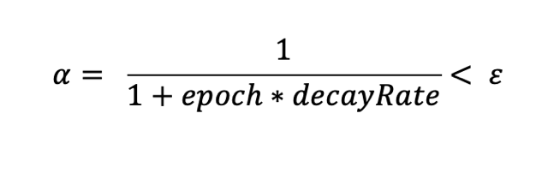
To achieve a balance between discovery and optimization, I tuned the decay rate to 0.1 against ​an epsilon​ (ε) ​of 0.1. This​ configuration permitted approximately ​90 epochs of​ trial-and-error exploration before ​the agent transitioned​ its focus toward performance-driven exploitation. While this initial discovery phase mirrors human problem-solving, the Deep Q-Network (DQN) operates as a model-free algorithm, highlighting a significant divergence from human intuition. Unlike humans, who possess a "model of the universe" that allows them to visualize maze layouts and anticipate dead ends, a model-free agent cannot perceive obstacles beyond its current state; it must physically encounter them to update its internal values.

Despite this lack of foresight, the agent’s action-value function eventually converged through repeated environmental interaction and the application of the iterative Bellman Equation (Liang et al., 2025). This iterative training process culminated in a highly efficient policy. The agent recorded its initial successful navigation as early as the second epoch and reached a consistent 100% success rate by epoch 248, demonstrating a complete mastery of the optimal path to the treasure. To implement this architecture, I utilized a neural network to map action-state pairs, effectively approximating the optimal Q-value for every potential movement within the maze.
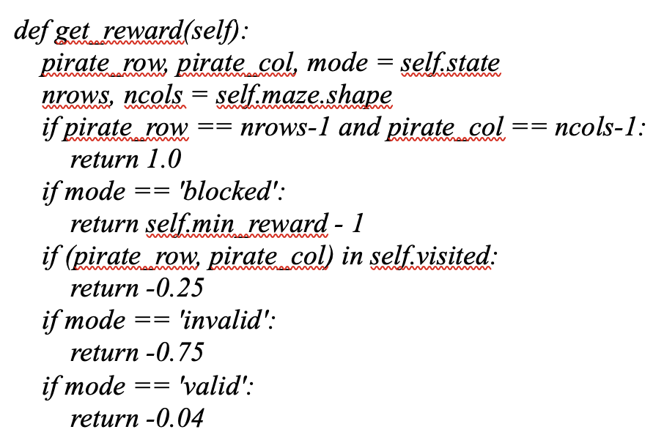
The agent’s decision-making is steered by a reward function that provides instantaneous feedback based on the current environmental state. In alignment with reinforcement learning theory, the agent refines its action-value function through continuous environmental interaction and the processing of these numerical reinforcement signals (Liang et al., 2025). Specifically, my implementation assigns a +1.0 reward for successfully reaching the treasure, while incorporating negative weights for hitting obstacles, revisiting previously occupied squares, or attempting invalid moves to penalize and discourage inefficient navigation.

The transition from initial discovery to optimized performance was managed through a decaying epsilon-greedy strategy. Under this framework, the agent’s action selection is determined by a dynamic threshold: if the calculated decay value exceeds epsilon (ε), the agent executes a random "exploration" move to further map the maze layout. Conversely, once the value drops below the designated threshold, the agent transitions to an "exploitation" phase. In this state, it leverages its accumulated experience to select the optimal action specifically the one with the highest predicted reward by utilizing the np.argmax function.
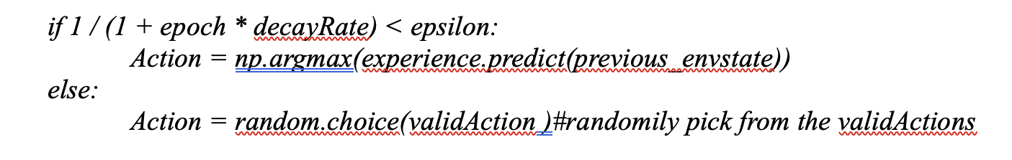
This decay mechanism ensures the agent comprehensively samples the state space during the initial stages of training before eventually converging on a stable, high-performing policy (Liang et al., 2025). By epoch 248, the neural network had successfully optimized the navigation route, resulting in a consistent 100% success rate.
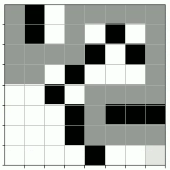
Visualization of the optimal navigation path generated by the DQN agent. The pirate's trajectory is indicated by the 80% shaded cells, leading to the treasure marked by 50% shading

References
Chen, Y., Schomaker, L., & Wiering, M. (2021). An investigation into the effect of the learning rate on overestimation bias of connectionist Q-learning. Proceedings of the 13th International Conference on Agents and Artificial Intelligence. https://doi.org/10.5220/0010227301070118
Liang, J., Miao, H., Li, K., Tan, J., Wang, X., Luo, R., & Jiang, Y. (2025). A review of multi-agent reinforcement learning algorithms. Electronics, 14(4), 820. https://doi.org/10.3390/electronics14040820

